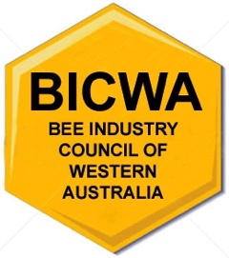
DIRECTORS NOMINATION FORM
Election 2025

- I, the undersigned, being a member of the Bee Industry Council of WA (BICWA) nominate

(Name)

(Address)

- Nominated by:

(Print name) (Signature)

The nomination is herewith accepted and the undersigned agrees to act as director of BICWA:

________________________________________________________________________

Nominee (Print name) (Signature)

Dated:

- PLEASE NOTE:

- You must be a member of the Bee Industry Council of WA (BICWA)
- Nominations require acceptance by the Nominee in writing
- the Nominee it not ineligible to be a director under the Act (not under 18 years of age, under financial restrictions of the bankruptcy process)
- the Nominee provides a bio, including current activity within the bee industry and motivation statement why to become a director, to the company Secretary before closing date
- Nomination forms need to be received on or before the 14 September 2025.

Forms to be sent to:
info@bicwa.com.au
Bee Industry Council of WA (BICWA)
Secretary
PO Box 1105
Bentley DC 6983

Office use:
Form received: ____________

